Name: ___________________________Class: _____ Date: ___________
Meet Barack Obama

Here’s the scoop on the President’s life
AUG 27, 2012 | By TIME For Kids Staff
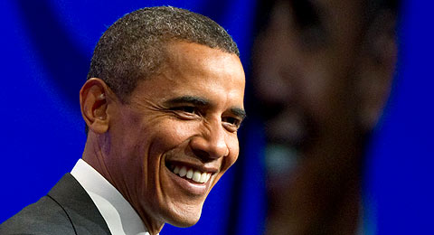
SAUL LOEB—AFP/GETTY IMAGES

Barack Obama, Jr. was born on August 4, 1961, in Hawaii. The name Barack comes from the Arabic and the Swahili words meaning "blessed." Obama's parents were students at the University of Hawaii at Manoa when they first met. His father, Barack Obama, Sr. was from Nyanza Province, Kenya, and his mother, Ann Dunham, was from Wichita, Kansas.

Young Traveler
When he was just two years old, young Barack's parents separated. His father eventually moved back to Kenya. His mother stayed in Hawaii. She later married Lolo Soetoro, a University of Hawaii student from Indonesia. The family eventually moved to Jakarta, Indonesia. There, his half sister, Maya, was born. Barry, as his friends and family liked to call him, lived in Indonesia for four years.

When Barry was ten years old, he moved back to the United States to live with his maternal grandparents, Stanley and Madelyn Dunham, in Hawaii. He attended Punahou, a prep school, and filled his days body surfing, hanging out with friends and playing basketball. He loved to play basketball. Even today, Obama plays in regular pick-up games with friends.

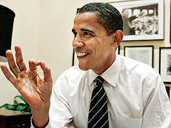
MANUEL BALCE CENETA—AP
Before he was President, Barack Obama was a U.S. senator.

College and Beyond
For college, Obama went to Occidental College in Los Angeles, California. He later transferred to Columbia University in New York City. During his college years, Obama started going by his full name, Barack.

Obama went on to earn his law degree from Harvard University, become a civil rights lawyer and law professor. Obama met his future wife, Michelle Robinson, in Chicago, Illinois. They later married and had two daughter: Malia, now 14, and Sasha, now 11.
Obama served as an Illinois State Senator for eight years. In 2004, he was elected to the U.S. Senate. At the 2004 Democratic National Convention, Obama gave a speech that captured listeners' attention and helped him gain enough recognition to begin vying for the 2008 Democratic presidential nomination.

On January 20, 2009, history was made when Barack Obama became the 44th President of the United States—and the first African American to hold the nation's highest office. Two million people stood outside the Capitol Building in Washington, D.C., to hear Obama's Inaugural speech.
---
His victory was important because he ran on the ideas of change and hope. One big change that we saw in the 2009 election was the influence that minority populations and young people had in deciding who would run our nation. For almost all of this country’s history, older, typically white Americans had led the way in deciding who would be president.

Joe Biden is Obama’s vice-president.

DIFFICULTY RATING: ____

