Name:_______________________________________________ Class: __________ Date: _________________
WEEBLY WEBSITE SCAVENGER HUNT

DIRECTIONS: 1. Visit the Social Studies class website by typing in or cutting and pasting the
url: lefort.weebly.com. This should bring you to the homepage (Home).
If you know how to, you may want to bookmark this site.

2. To the best of your ability, follow the directions from each TASK provided.
3. Choose a color other than black (or something really light and difficult to
read) to record your answers.

NOTE: This site is Smartphone compatible but you may have to answer the tasks directly in email if you can’t open or access Microsoft Word.

#1: Welcome to the Homepage. In the background you see a picture of Mayan ruins in Guatemala. Use the “Maps” page and look at the “Political Map of North America”. You can access the “Maps” page by clicking on where it says “Maps” on the picture...
or you can scroll down to the links down below.

TASK: List two countries that are bordered by Guatemala:

#2: Continue scrolling down to the map titled “Early Human Migration”. Using that map...

TASK: How long ago did humans reach the Americas?

#3: Visit the “Contact” page. In addition to my school email (MLEFORT@SKSCHOOLS.NET), what other email can you reach me at if you need to?

#4: Using your own words, explain what a WAI is.

#5: How many videos have been uploaded on the “Videos” page?

#6: Which website will assist us with our use of “Flashcards”?

#7: Stay on the “Flashcards” page and click on the link for “Social Studies Standards”.
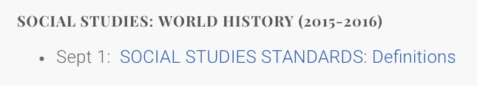
TASK: List the five standards that we will be studying this year.

#8: There is also a page on our website titled, “Schedule of Events”. If you visit this site you will notice there are three different types of events. The first is “Short Term” events. What are the other two?

YOU ARE ENCOURAGED TO FURTHER EXPLORE THIS WEBSITE. WE WILL BE USING IT BOTH IN AND OUTSIDE OF THE CLASSROOM THROUGHOUT THE YEAR.

FRIENDLY REMINDERS:
- Make sure you have typed your answers in a color other than black.
- Email this completed assignment to MLEFORT@SKSCHOOLS.NET by Friday, September 4 for full credit.

